From “Returning Home… (https://www.dropbox.com/s/0nrh2vemlfkfnxn/ReturningHome%2001.06.14%2C%20Final%20w%20Frame.docx?dl=0
Using the Enneagram - Knowing Our Personality Type 134

See also:
Using the Enneagram – Growth & Development 137
Energy Flow in Enneagram 139
The Enneagram + The Missing Three 142)

Using the Enneagram - Knowing Our Personality Type

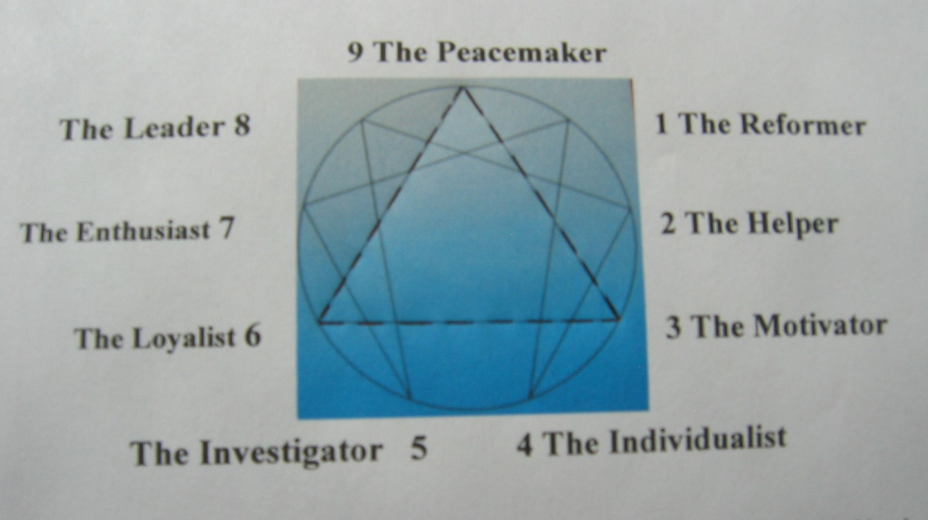

The Enneagram can be a useful tool to help in understanding the role of instincts, thinking, and feelings in our life.
“Ennea” is Greek for nine, the number of points shown on the figure above. The symbol is a combination of the Law of Three, shown as the triangle connecting the numbers 3 - 6 - 9. The other numbers 1 – 4 – 2 – 8 – 5 – 7 – 1 are connected in a sequence that is the quotient of one divided by seven (1/7).
The symbol has been used extensively in studying the nine Personality Types. It provides help to determine your basic personality type from initial information on whether you are instinctive, feeling, or thinking; and, to what degree you express yourself on these three different functions. Based on these basic personality types, one can be aided to identify strengths and weakness, levels of development, and direction of integration and disintegration.
The enneagram is useful as a resource to an in-depth study of the subject of this book regarding the answer to the question “Who Am I?” As a minimum, the enneagram can help the reader to determine the personality types of the seven dwarfs in accordance with his respective understanding of the energy described in the Chapters. Of course, using the seven dwarfs is only to aid our memories in correlating the many factors that are used to describe these various energies. Ultimately, the sum total of these energies equate to the True Love that awakens Snow White.
It is stated in the “Personality Types” by Don Riso with Russ Hudson, that we have to transcend the ego that has a total grip on our lives by “learning how to be open to love. Only love has the power to save us from ourselves. Until we learn to truly love ourselves and others – and to accept the love of others – there can be no hope of lasting happiness or peace or redemption.” The Mysteries of the Seven Dwarfs is all about how this love flows through us as “inner light.” And, how this “inner light” blooms and ignites into enlightenment.
Once you understand your type, then you can begin to understand others. This is proven to be helpful to a supervisor in the assignment of personnel.
Once you know your dominant type, it becomes an indicator of your strengths and weaknesses. When you know where you are within the connecting lines, you shall have an indicator of your movements toward one or the other of the personalities to which you are connected.
Relationships among the various types can provide for interesting observations: The strongest attractions are between two people who are opposite from each other in the circle; and, the strongest bonds can be developed between two people that are adjacent to each other in the two symbols. They could complement each other in their strengths and weaknesses. Note, however, that we each are adjacent to two others and there are potential complications.
The table from the text is reproduced here in the Appendix for easy reference:
TRIAD TYPE | EXPRESSION | BASIC PERSONALITY
PHYSICAL/  INSTINCTIVE | Over Expression { }(R)  “Gut” reactions | 8 The Leader  Selfless, big-hearted
PHYSICAL/  INSTINCTIVE | Out of Touch { }(O)  Inner stability & peace | 9 Peacemaker  Fulfilled, inner integrity
PHYSICAL/  INSTINCTIVE | Under Expression  of feelings { }(Y) | 1 The Reformer  Realistic, mature, well-balanced
FEELING | Over Expression  Focus on positive | 2 The Helper  Giving, Service
FEELING | Out of Touch  Suppress feelings { }(G) | 3 The Motivator  Accepting self
FEELING | Under Expression  Thinks about feelings | 4 Individualist  Creative, Listens to inner self
THINKING | Over Expression  Thinks vs doing { }(B) | 5 Investigator  Synthesize, makes connections
THINKING | Out of Touch  Circular Thinking { }(I) | 6 The Loyalist  Secure, self reliant
THINKING | Under Expression  Incomplete thoughts }(V) | 7 The Enthusiast  Loves life unconditionally
Table 3. Finding Your Personality Type

“Basic Personality” is our dominant type. However, we are a blend of adjacent personalities, especially at the “Wings” as indicated in the main section of this book. We can have aspects of these adjacent personalities to varying degrees. In reality we could exhibit each of the nine personalities to a certain degree.

Each person is a unique individual and remains that type for the rest of his or her life; except that there is some open-endedness resulting in integration/disintegration as a result of psychological growth/deterioration.

Direction of Disintegration: 9 – 6 – 3 – 9 : 1 – 4 – 2 – 8 – 5 – 7 – 1

Direction of Integration: 9 – 3 – 6 – 9 : 1 – 7 – 5 – 8 – 2 – 4 – 1
(See “Using the Enneagram – Growth and Development” and “Energy Flow in Enneagram” in this Appendix)

Ultimately, the goal is to progress completely around the Enneagram, integrating the strengths of what each type symbolizes and acquiring the active use of the healthy potentials of all the types.

We can work to become a balanced and fully functioning human being through experiencing the important aspect that each of the types can teach us.

Which type we begin life with is ultimately unimportant…..

The colors shown under the “Expression” column is my attempt at correlating the spectrum of the rainbow to the different personalities. “Energy is Energy.” Our personalities are visible representations of the light that flows through us. The colors in the rainbow show the spectrum of light as it passes through the water molecules in the air. Our personalities, actions, and reactions must then relate along a spectrum similar to the colors of the rainbow. The red color can be associated with the aggressive, “gut” reactions of an eight type. At the other side of the spectrum, the violet color can be associated with the unconditional love that we ultimately wish to experience, located within ourselves and on the inner side of the rainbow.

