Summary: The Digestion Cube – Things to Know
- Describes the process of digestion of the three fuels required for life: two of which nature has provided the digested mechanism:
  - Fuel of Food we eat – digested by the stomach
  - Fuel of Air we breathe – digested by the lungs
  - Fuel of Impressions – digested by self-remembrance, consciousness, awareness
- Average development has humanity existing at the lower level of the “Cube” with the fuels not efficiently or effectively digested
- A “shock” that generates “inner light” takes us to the upper level of the “Cube” where higher energies results in a shift of our being to exist in a Spiritual State beyond the material spherical earth.
  - The digestion of AIR can result in the development of a Mental Body; and,
  - The digestion of IMPRESSIONS can result in the development of the Emotional Function to an Astral Body
- The efficient and effective digestion of AIR can be achieved through practices and disciplines as YOGA: For a collaborating Resource see www.liliaroman.com (Please copy & paste to view referenced website)

From Reference book, Pages 74 ff https://www.dropbox.com/s/0nrh2vemlfkfnxn/returninghome%2001.06.14%2C%20final%20w%20frame.docx?dl=0

“Gap #1: The Shock of “Inner Light”

During my journey, I got an education and practiced as an engineer. Engineers are trained to observe details, make calculations, and prepare clear, understandable documents. This was the paradigm in which I existed in the manifested, lower level world. The paradigm in Nature is that the blueprints for a tree, a flower, a fish, and the human species are encapsulated in seeds and fertilized eggs. The right environment provides proper nourishment. Soil, water, sunlight energy, or nourishment from a host is required in Nature for its creations. The process in this creation has evolved over millions of years to maintain a harmony that exists all around us.

What, then, should be the process to implement the open ended idea of “he that believeth on me, the works that I do shall he do also; and greater works than these shall he do; because I go unto my Father”? We may have to discuss whether He is speaking of the teachings and cures that are associated with His work. If these works are what He referred to, could we then eventually evolve in such a way as to find solutions to the disharmony in our individual and collective lives? And, how could this interjection be done?

Again, we have to be alert to the paradigms in which we think, feel, and act. There is a huge resistance to this idea or lack of belief that we can interject ourselves into our human state of being. Being able to change our conditions of health, ways of thinking, lack of emotional control does not seem to be a viable option in our normal, lower level state. The results from the efforts of the devout, the religious orders, monasteries, the prayer groups seem miniscule relative to the huge problems of poverty, racism, bigotry, and multitude of other conditions causing pain and suffering. We are reminded that ”we should not swear by thy head, because thou canst not make one hair white or black.” We run into a blank wall when we ask the question “What else can we do?”

We know there are other paradigms. There are some indigenous cultures that have practices to interject themselves into the events of Nature. Isn’t it true that in the event of a drought, rituals have been used by certain cultures to bring rain? Isn’t this an effort to influence the forces of Nature?

Concentrating only on the words in ancient works, I found that I could outline the themes that support the possibility of our access to universal energy. I have to go cautiously on this. Otherwise, I may run into the forces of those influenced by ideas that the “earth is flat.”

Nevertheless, I shall initially use two universal laws described by Gurdjieff as the framework in outlining the Sermon on the Mount in order to better understand its meaning.

The first of the universal laws, the Law of Three, describes that there are active, passive, and neutralizing forces in the process of creation. This is the beginning of anything and everything in the universe. Examples can be seen all around us. There is the sperm, the egg, and the womb in which a human baby begins its journey. There is a boss, a worker, and the bonding in an the office through which products and projects are created and completed.. There is Jesus, a cripple, and the faith and belief of the cripple in which a transformation is performed.

Perhaps, we must first discuss our relationship to a universal force. There are many words of Jesus describing us as children of God and that we share all His powers. He is not obscure or obtuse or vague about this. He separates us from the lilies in the fields and the ravens in the sky. If we, as human parents, can provide for our children; similarly, He declares that we are provided for in all ways as children of God. How can we not believe Him if we believe at all? However, in many rituals and references there is an underlying sense that the separation between us and the universal force prevents us from fully accepting this relationship. For Christians, this began with Adam and Eve disobeying and being exiled from paradise!

I, Elihio, the Prodigal Son returns and is welcomed back to take my place as an equal to my older brother who remained with Father. This is the first paradigm that I must fully understand to dissolve many thoughts, words, phrases, rituals, and other associated constraints that I have had. My brother and I are both children of Father and with this as a starting point to describe our relationship, “we both can do works that He can do; and, greater works than these shall we do because Jesus went to his Father!”

Ask people who have been exposed to the lessons of the Prodigal Son and you shall find very similar responses that speak of forgiveness, joyfulness, and facing the jealousy of the older son. How many go on to talk about the Prodigal Son going forward to take his obligations and responsibilities alongside his siblings and his father? Is this not what we are also to do in our life. We have to take responsibility for who we are and for what we are to become! It is not enough to simply think about being “loved” and living happily ever after.

There are a number of interesting references regarding the three forces, especially with the soul. The children’s story entitled “Snow White and the Seven Dwarfs” has a prince waking up Snow White with a kiss. The seven dwarfs were her caretakers during her deathlike sleep. Does this not have the hidden meaning of our souls needing to be awakened by some sacred idea? Could it be that the seven dwarfs represent the lack of development of our seven major glands in our evolution as human beings? Aren’t the seven dwarfs representative of the seven chakras as described in the Eastern traditions? Are not these seven chakras the same as the seven major glands in the endocrine system?

Interestingly, a group working with Edgar Cayce established that the Lord’s prayer addresses the seven major glands! In other words, Jesus taught us a prayer to develop our physical connections to the universal forces to increase the flow of universal energy.

In my introduction to Pranic Healing, a practice of healing with the energy flowing through us, the chakras are the points in which our physical being is connected to universal forces. It teaches meditation practice with the practitioner visualizing universal energy flowing down through the upper chakras in the crown of the head, along the spine, and grounded ten feet into the earth. Then, energy is circulated through the lower chakras to tap from the universal energy to energize our physical being.

I realized after many years that this is similar to how electrical power is brought into our homes: this power is generated at a far off power plant and transported at high voltage to our cities. A transformer near our homes reduces the high voltage to 110 or 220 volts A.C. depending on what part of the planet we find ourselves. These transformers allow us to use the electricity in our homes for our appliances and computers.

Using the above understanding I began to recite the Lord’s Prayer in the following manner:
- In the first part of the prayer, the universal energy flows through the pituitary gland (“Our Father who art in heaven”), the pineal gland (“hallowed be Thy Name”), and the thyroid gland (“thy will be done”) and grounded ten feet into the ground.
- In the rest of the prayer, the energy is circulated through our organic transformer consisting of our lower glands (“Give us this day our daily bread…..”) that reduces the energy sufficiently for our daily use.

The purpose of the prayer then is to heal the glands in our system to a level that their energy capacity becomes sufficiently large to ignite our “inner light” such that we become enlightened.

There is also the interesting explanation of a group working with Edgar Cayce related to the meaning of letters to the seven churches described in the Revelations, the last chapter of the bible. The Laodicean church is described by Edgar Cayce as representing the pituitary gland in our endocrine system, which is the master gland. The letter chastises the Laodicean church and states that it must be hot or cold, and not be just lukewarm. Does this not tell us that our soul has to awaken and has to become active, to become responsible, to take action whether it be hot or cold in its occupancy of our physical being?

Gurdjieff describes The Law of Seven as governing all the processes in the universe. The Law of Three describes the birth of an idea. Thus, when we get an idea, the Law of Seven must be used as the process to bring the idea to reality.

Interestingly, in our inner self there appears to be an option within the Law of Seven. A review of the words of Jesus shows that, perhaps, these seven steps could be unnecessary: WE JUST NEED TO HAVE FAITH AND BELIEF. The belief of others was enough to raise Lazarus from the dead. The belief of a cripple was enough to have him pick up his bed and walk away. The belief of an apostle initially had him walking on water towards Jesus and then sinking as he falters in his belief. Jesus clearly states that had we the belief the size of a mustard seed, the least of all seeds, we can move mountains.

The majority of us, however, do not even have the capacity to convey enough faith and belief to move even a pin floating on water. (This is an exercise in a text prepared by Mouni Sadhu on Concentration. How far do we have to evolve to be able to move a mountain?!) Therefore, the balance of the teachings of Jesus painstakingly provides the details of how we can evolve. If we cannot generate faith and belief, then He appeals to our intellectual function that can follow the more normal process of the Law of Seven operating in our outer selves. He saw that our evolution would lead us on a path of focusing on the development of our intellectual function. This is where we are today where our educational systems and the direction of our technology have been on enhancing our intellectual functions.

For those of you willing to explore further outside the box (much further outside the box), consider the possible symbolic meaning of the beheading of John the Baptist. May this not be a metaphor to reveal to us that, with the advent of the teachings of Jesus, we should have separated ourselves from our thinking function and focus on his teachings of the heart? He stated that John was the greatest born of woman; but, the least in Heaven is greater than John. So, by all means, let us entertain this quest of attaining this higher level by focusing on our feelings, our heart function! After all, we can also depend on the mysteries of the seven dwarfs from which to receive the energy.

Can the power of faith and belief be understood and developed through an understanding of the Law of Three? Jesus stated that the first great commandment is “thou shalt love the Lord thy God with all thy heart and with all they soul, and with all thy mind and with all they strength;” and, the second “is like unto it, Thou shalt love thy neighbor as thyself.” Within the context of the Law of Three, I am considering that God is the active force, we are the passive force, and the third force is the love that he is asking us to have of him and our neighbors. Our “neighbors” would be a catalyst in developing this love.

This strikes me as being very familiar to what science understands regarding the generation of energy in the sun and stars. The sun and stars in our universe exist and generate energy through fusion, the joining of two elements as a result of high temperatures and pressures under the force of gravity resulting in the creation of energy greater than that required to fuse these elements. The residual energy is radiated throughout the universe to give life to all living things. Gravity, that which creates the high temperatures and pressures, is not yet fully understood by our science. Gravity is a force of attraction in the universe. On this planet, we experience relationships as a structure through which the force of attraction acts.

Isn’t fusing with God what Jesus is describing in the first of the two great commandments? There is some suggestion in the literature that love, since it is a force of attraction, is an equivalent in our plane of existence to the gravitational force in Nature. However, this love is not often enduring and does not result in creating magnificent things anywhere similar to the sun and stars. It appears that only special relationships that can convey a huge amount of love can build a Taj Majal. However, isn’t the containment system, the third force in the Law of Three, sounding very much like the relationship that we are to have for God and our neighbors? Certainly, the attainment of a relationship structure among the universal force, our neighbors and us through which unconditional love can flow should be our goal.

There are certain deep-seated actions by humanity regarding the role of love in our evolution. Love is the overwhelming subject of songs, books, paintings, and other means by which we communicate. But how much of our efforts lead to reaching a sufficiently intense concentration and speed of energy that is needed to make a difference? It is my proposal that only by going into our inner self and understanding the processes in which the foods we eat are digested and transformed into the level of energy required to grow and develop can we evolve.

We can do this by developing a center of gravity within which we can contain the energy that we generate. Then the same process that occurs in the sun and the star takes over and the result is enlightenment as taught by Buddhism.

The ideas of Gurdjieff regarding the Law of Seven provide some approaches we can take in generating the energy required to nourish our love. His ideas regarding the Three Types of Food were introduced in the second chapter. The three types of food separately result in nourishing our intellectual, moving/instincts, sexual/reproductive and emotional functions. Figure 2.1 shows that the practice of self-remembrance is required to digest impressions to produce energy that fuels our emotional function.

In the discussion that follows, I shall be discussing the various sections of the Sermon on the Mount (SOTM). I divided the sections into the sections familiar to me that correlate to the seven steps and the two gaps in the Law of Seven that I have used extensively in my activities and projects.

{The key point is to understand who was being given the sermon. In reverse engineering the SOTM, please fully understand that the final result is “that those who hears and does these things is like someone building a house on rock.” For a moment consider that our physical being is the house. Then consider that the SOTM may have been addressed to THE SOUL/SPIRIT WITHIN… Then much of what is stated in the SOTM are directions, guides, instructions to the soul/spirit for the upgrade, renovation, adjustment of our physical, mental, sexual and emotional functions.}

In applying the Law of Seven to our inner development, the first step must be to realize and our real self; i.e., that we are really spiritual in nature. An approach is to use the example of Sri Ramana Marsharshi in the practice of the Vichara: asking the question of “Who Am I?” It is like understanding the nature of the land upon which we wish to build a structure. We need to define its size, its ability to support a structure, and its relationship to the environment.

The second step must surely be to define the teachers that “let their light so shine that their works are known to us to become in harmony with the Divine.” Their “light,” the truths to which we are “initiated” all serve as nourishment to awaken our inner self, our mind, and our emotions. Through parables, He attempted to cover the many truths. He states that we must be as a child to enter the Kingdom of Heaven; he describes the Kingdom of Heaven as like finding a treasure in a field and going home to sell all one has to possess the field. He is describing the center of gravity, the focus, the passion, the intensity we must demonstrate towards a treasure.

The third step is in focusing on a specific vision, knowing our aims, and understanding and applying our values. At this time in an engineering project all energy would be devoted to drawing the details of pictures (shapes, colors) and creating blueprints, numbers (calculations to determine sizes and materials), and specifications (word descriptions).

Jesus realized that we can develop many aims; but he wants us to develop “a single eye” to become full of light. It is interesting that the spelling of “eye” meant no sense to me and it took a full year, using Gestalt theory, to finally come across the works of Gurdjieff to make some sense of it. In his works Gurdjieff described that our being is composed of many “I’s” and as a result we end up doing nothing. The many I’s compete for our limited energy resources and we arrive at the end of each day, year, and life having just survived. In mathematics, the sum of the vectors of the many I’s is zero.

The words of Jesus should then be understood as “when your ‘I’ is single, thy whole body also is full of light.” Light from the sun and stars is commonly known as the source of all life in the universe. The body thus reaches its maximum transforming capacity when the “I” is single and the body is full of light. This third step brings us to a clear set of blueprints through which energy can flow to eventually manifest our aim in the outer sphere; i.e., to materialize our aim.

A “shock” has to be introduced at the third step in the Law of Seven to bridge the gap between the third and fourth steps. In our physical bodies, this “shock” takes the form of air as shown on Figure 2.1.

At this point in my investigation and research I languished for a long period of time. I was caught in the habits developed during my long journey. Despite a review of all my experiences, I could not find any that allowed me to progress.

I became morose and began to feel the pressures that come from inactivity and/or lack of progress. Fortunately, the energy became one of humbleness and realization that I had to turn to Father. Then, it happened. The phrase at the end of His Sermon on the Mount stated, “he who hears and does these things is like someone building a house on rock.” As an engineer, I immediately determined that the process of “reverse engineering” of his sermon must surely reveal the answers to many of my questions.

During this “reverse engineering” process of the sermon, I noted that there are many references to energy and light. By outlining the sermon and placing the various sections into the seven steps, those listening to the sermon are giving choices starting at the fourth step. (See Appendix for Notes on Reverse Engineering.)

At the fourth step there is the choice of laying out treasures on earth or in heaven. At the fifth step there is the choice of serving mammon or God. At the sixth step, there is the choice of judging others or not judging others. I concluded that there must be a “shock” at the third step that results in the process being taken to a higher level. This presumption allowed me to develop the three dimensional sketch shown in Figure G1.1, below.

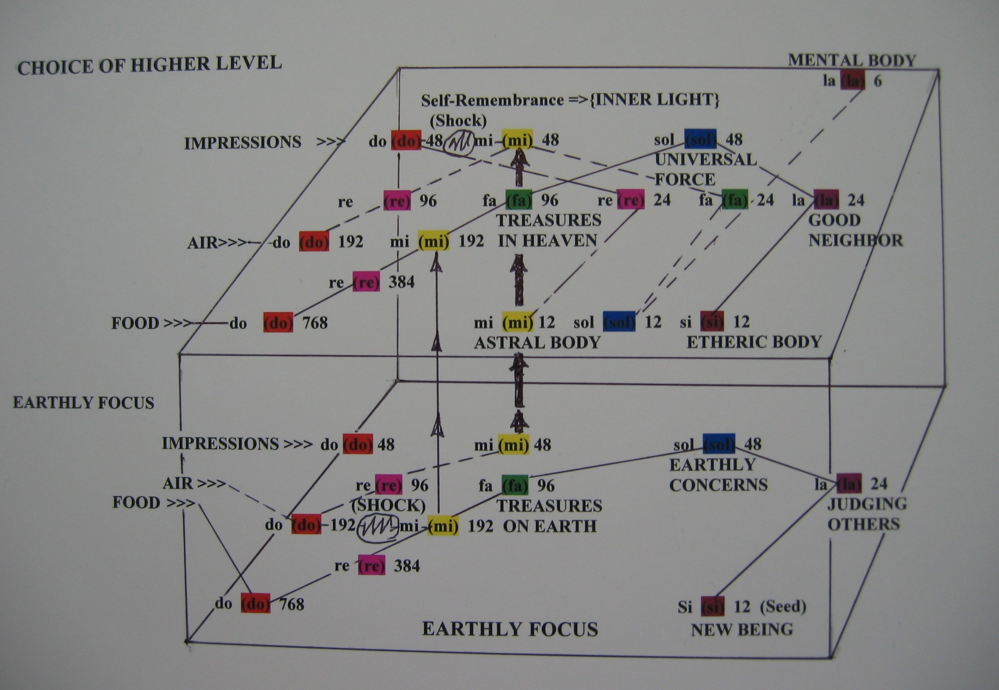
Figure G1.1: The “Shock” of “Inner Light” at Note “mi” Results in Upper Level Existence

This was the paradigm shift I was looking for! This was the connection to a higher level that I sought!

I arrived at the notion that the shock of an “inner light” must be equivalent to the shock of “air” to propel a person to the higher level. As in the function of “air,” without this “inner light” there cannot be an existence at the higher level.

With this concept of an “inner light” I determined that I could better understand the answer to the question that arose midway through my journey regarding “what is it that I am doing from day to day that shall lead to something of permanent value?” This question has drawn me these many years step by step to discovering the words in the Gospel of John, Chapter 6:44 “No man can come to me, except the Father that sent me draw him.” In this chapter, Jesus states that “he is the bread of life”; “he that eats this bread shall have eternal life”; “it is the spirit that gives life”; “the words that I have given you are spirit, are life.” Thus the use of the energy, the “inner light” within the words taught by Jesus provides the nourishment that results in that which is permanent!

I was ecstatic! Did this lead to an energy similar to that used by a chrysalis (also known as a worm) transforming into a butterfly? Does the flow of energy through this truth lead to realizing the thoughts and dreams that seem otherwise unrealizable at the lower level of existence?

I became energized in the thought that I, Elihio, the Prodigal Child, would be able to meet my obligations and responsibilities with Father and the family.

It was not one of the seven dwarfs that appeared to provide me with the energy for this development. At this critical juncture, it appeared that it was the “prince” that provided the “inner light” of love that awakened Snow White.

At the higher level, the impact of the mysteries of the seven dwarfs seems to diminish. Rather, they remain dwarfs and continue to provide their treasures and truths at the lower level where they provide subliminal messages to those existing at this lower level.

We cannot abandon the influences of the remaining dwarfs, however. After all, their energies have nourished us to this point, just as the dwarfs had to sustain Snow White during her death-like sleep. It is useful to know that we can become aware of and then be able to use these energies as part of the “Who Am I?’ exercise. Unless we know these energies they shall remain invisible to us and influence us in hidden ways. By shining “inner light” on these energies we can chart a path to be initiated to their truths and treasures so that we can shift to the upper level of existence. This is the goal of this story.

In observing these energies, the symbol of the Enneagram is another aide to help us see how these energies interact and combine to get the right results. The Enneagram combines the Law of Three and the Law of Seven into one symbol. It represents the flow of energy within the two laws.

First and foremost to consider if we want to interject ourselves into the flow of the events in Nature is that we develop an image and understanding of what we want to change and hopefully to visualize our ultimate aim. Take the examples of the workshops or seminars that were designed for the baby boomers to achieve success. These workshops and seminars have made the “baby boomers” very efficient and effective in becoming successful and wealthy in the material sense. The seventy six million baby boomers have accumulated a large percentage of the wealth of this country in great part to the success of these workshops and seminars. But what is their status today? What is the status of this country and the world today as a result of what these workshops and seminars taught us? The baby boomers are approaching the time when the question “what else can we do?” shall become increasingly important. The answer is in fully understanding the flow and role of light, the source of life, in our existence.

We can use the Enneagram to visualize the flow of light energy through the Law of Three as represented by the triangle in the Enneagram to generate images of our needs and desires. Then we turn our attention to the hexagram within the Enneagram to activate the process by which these needs and desires can be realized. We can make our efforts to increase the flow of these energies through mindfulness and acting from the heart. As we proceed through this book, we should be aware of these energies. See the Appendix for more details on seeing the energy flow in the Enneagram.”

